📊 STUDENT PERFORMANCE ANALYSIS USING HADOOP

👨‍💻 Student Details
Name: Raghvendra Pratap Yadav
Course: BCA (Data Science & AI)
Subject: Big Data

📌 Objective
The objective of this project is to analyze student marks using Hadoop MapReduce and Hive.
It helps in understanding how big data tools process and analyze datasets.

🛠️ Technologies Used
Hadoop (HDFS + MapReduce)
Hive
Python
Cloudera VM

📂 Dataset Description
The dataset contains student name, subject, and marks.
Raw Dataset:
Student, Subject, Marks
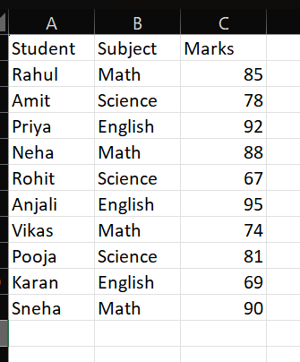

Cleaned Dataset:
Rahul,Math,85
Amit,Science,78
Priya,English,92
Neha,Math,88
Rohit,Science,67
Anjali,English,95
Vikas,Math,74
Pooja,Science,81
Karan,English,69
Sneha,Math,90

⚙️ Methodology
Data Preparation:
- Removed header row
- Converted into comma-separated format

💻 Hadoop Execution
Command used:
hadoop jar /usr/lib/hadoop-mapreduce/hadoop-streaming.jar
-files Mapper.py,Reducer.py
-mapper Mapper.py
-reducer Reducer.py
-input /input/cleaned_dataset.csv
-output /output
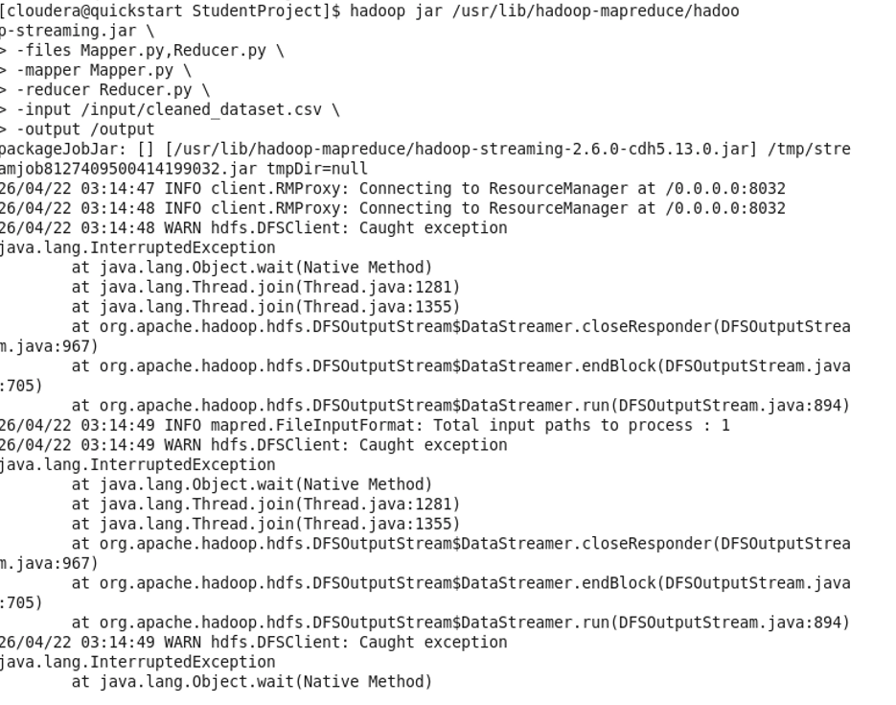
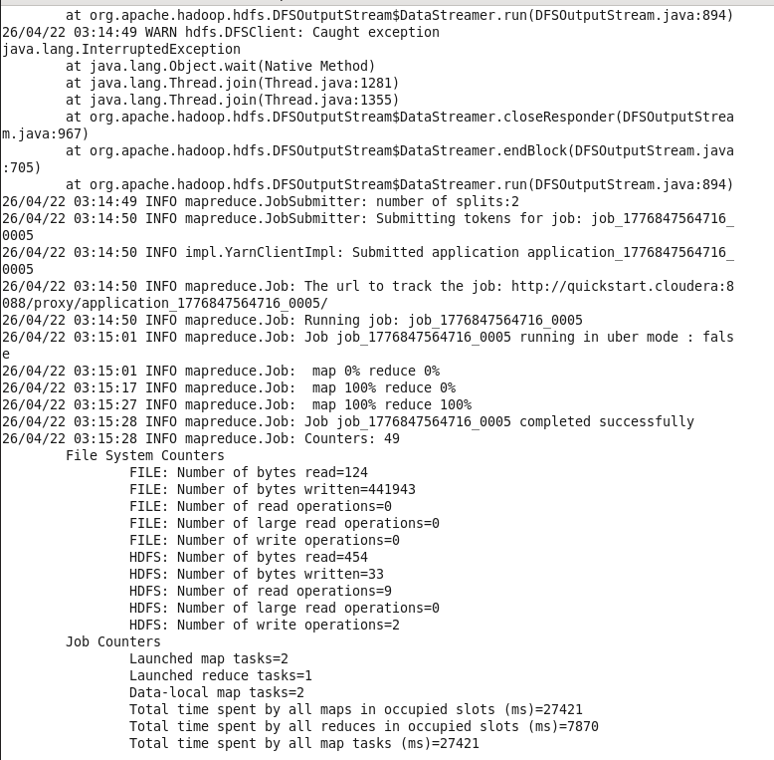
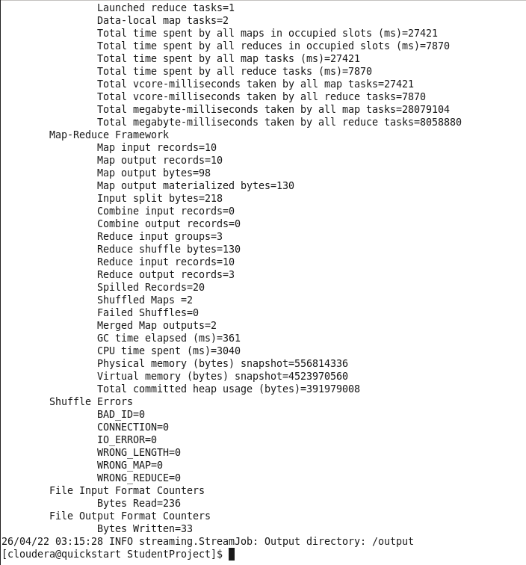

📊 Hadoop Output
English 256
Math 337
Science 226
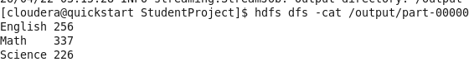

🐝 Hive Implementation
Create Table:
CREATE TABLE student_marks (
name STRING,
subject STRING,
marks INT
)
ROW FORMAT DELIMITED
FIELDS TERMINATED BY ','
STORED AS TEXTFILE;
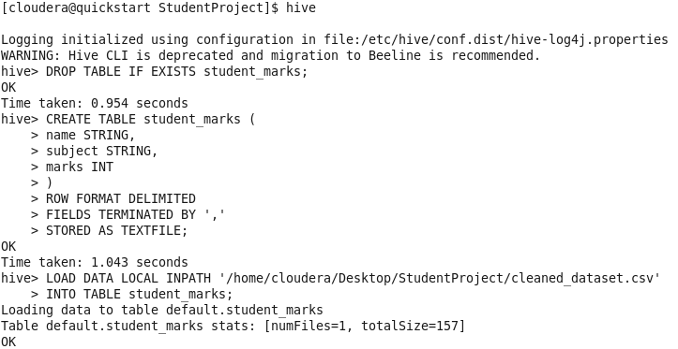

Load Data:
LOAD DATA LOCAL INPATH '/home/cloudera/Desktop/StudentProject/cleaned_dataset.csv'
INTO TABLE student_marks;

📈 Data View
SELECT * FROM student_marks;
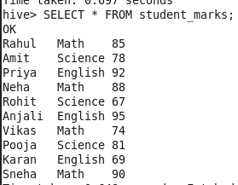

Average Marks
SELECT subject, AVG(marks) FROM student_marks GROUP BY subject;
English → 85.33
Math → 84.25
Science → 75.33
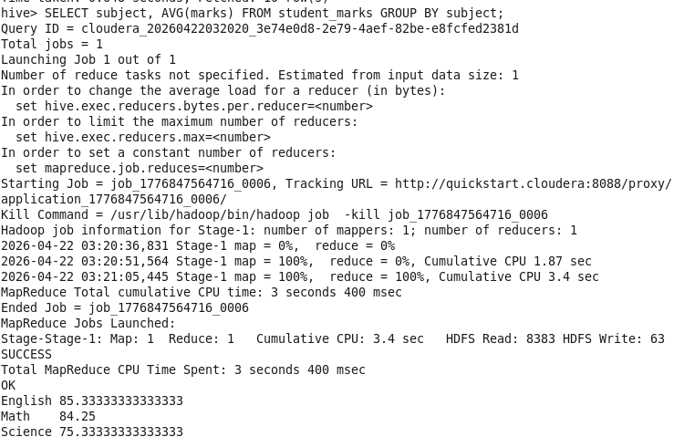

Total Marks
SELECT subject, SUM(marks) FROM student_marks GROUP BY subject;
English → 256
Math → 337
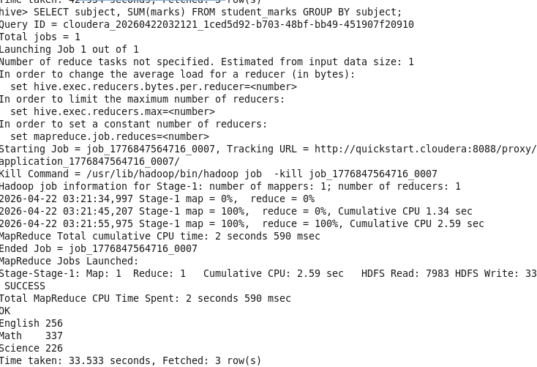

Top 3 Students
SELECT name, marks FROM student_marks ORDER BY marks DESC LIMIT 3;
Anjali → 95
Priya → 92
Sneha → 90
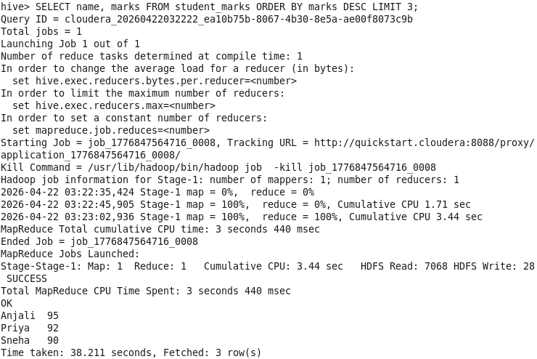

Maximum Marks
SELECT subject, MAX(marks) FROM student_marks GROUP BY subject;
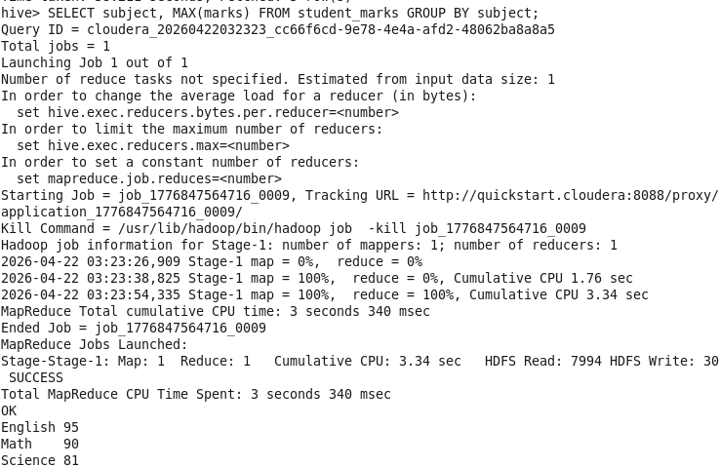

Minimum Marks
SELECT subject, MIN(marks) FROM student_marks GROUP BY subject;
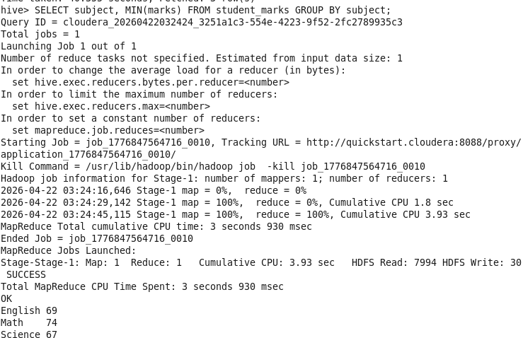

Count of Students
SELECT subject, COUNT(*) FROM student_marks GROUP BY subject;
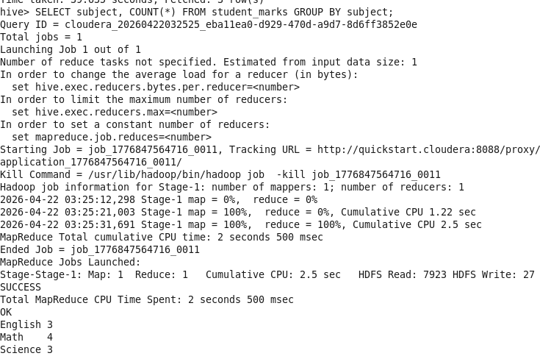

🧠 Conclusion
This project demonstrates how Hadoop MapReduce and Hive can be used to process and analyze data efficiently.
It provides practical understanding of big data tools and their implementation.

